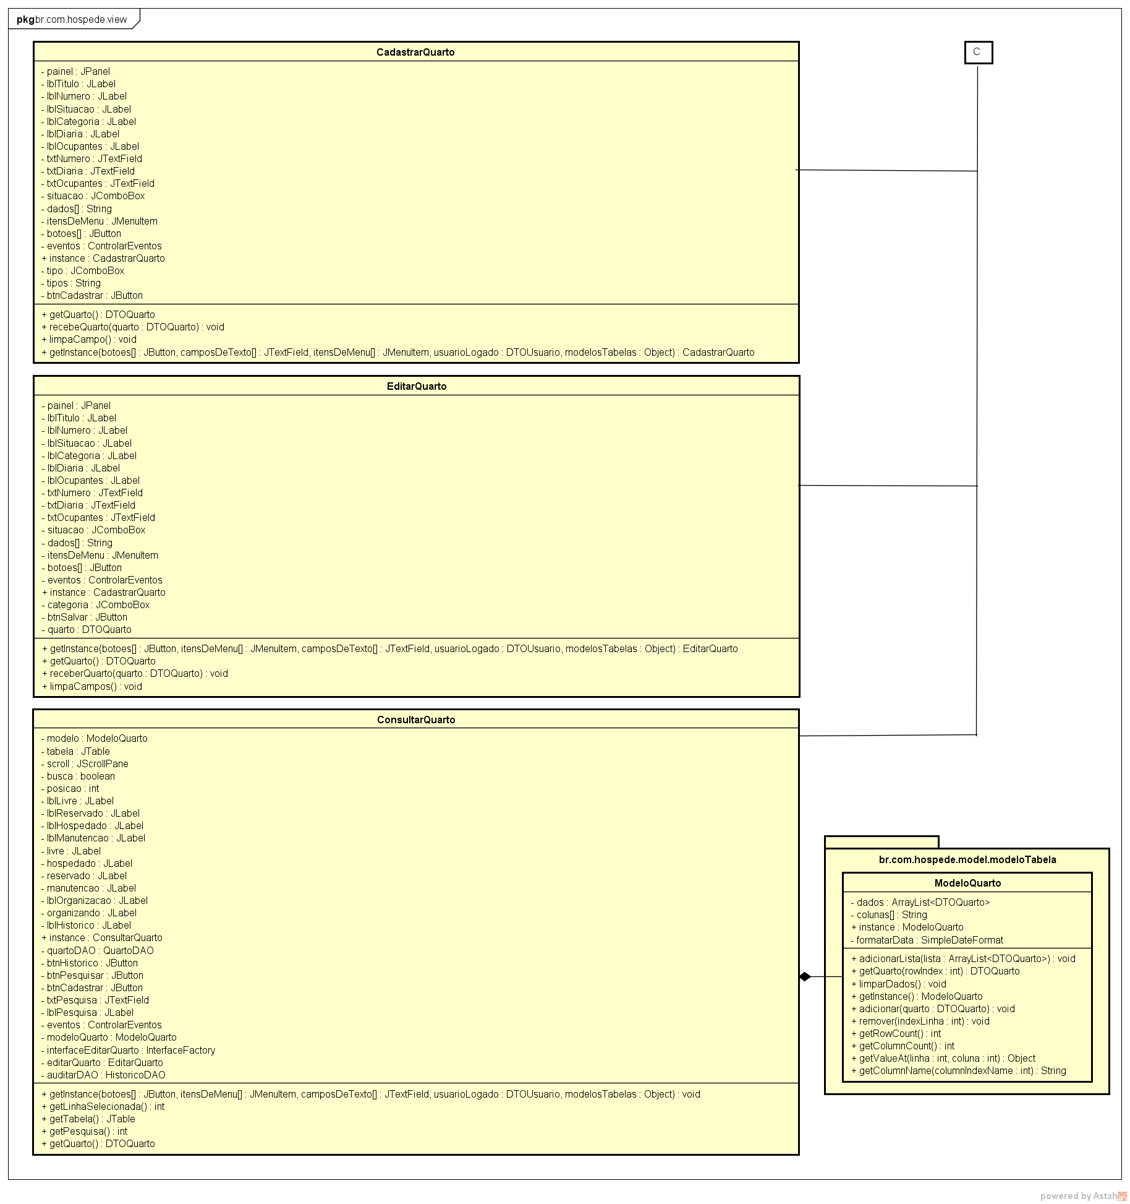

**Figura 8** – Diagrama de classes Camada view C

55